OWASP A5: SECURITY MISCONFIGURATION
1. Overview
This project shows how I built and tested a cybersecurity home lab using VirtualBox.
The goal was to find security misconfigurations on Metasploitable2 and exploit them using Kali Linux.
Ubuntu was used as a normal machine for network comparison.
The project includes:
- Scanning
- Misconfiguration identification
- Exploitation
- Impact analysis
- Fix recommendations

2. Lab Setup
Virtual Machines:
- Kali Linux (attacker)
- Metasploitable2 (vulnerable machine)
- Ubuntu (normal machine)
Network:
- Internal Network (labnet)
IP Addresses:
- Kali: 192.168.100.10
- Metasploitable2: 192.168.100.20
- Ubuntu: 192.168.100.30
Ping Tests & Connectivity:
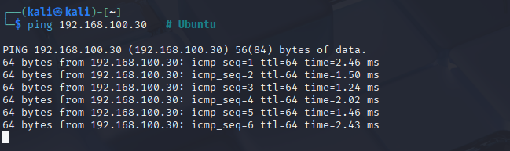
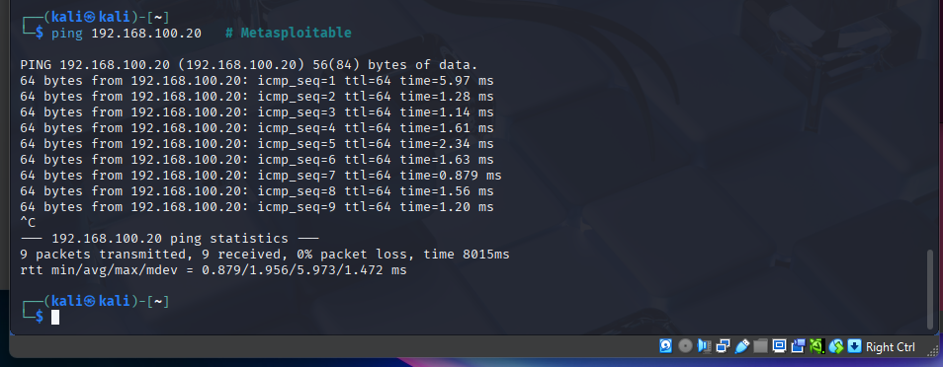
Nmap Host Discovery Scan:
Kali discovering the hosts in the internal network
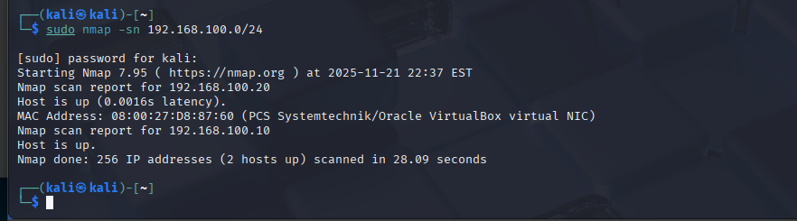
Full Nmap scan of Metasploitable showing open vulnerable services
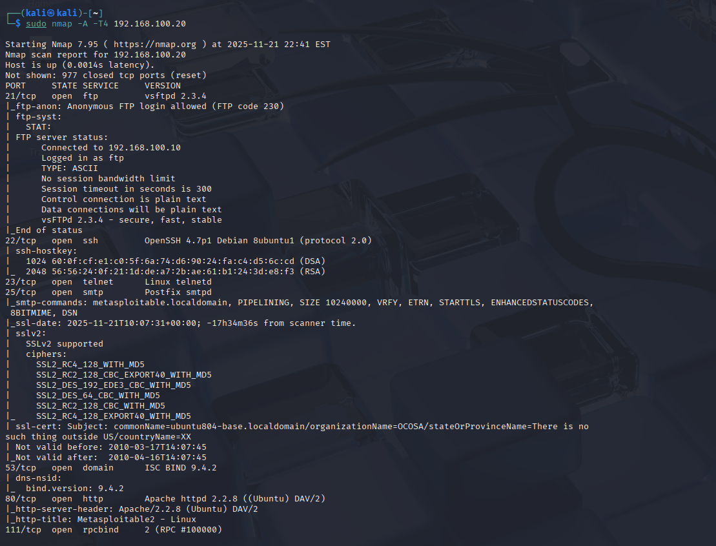

3. Misconfigurations Found (OWASP A5)
These are the misconfigurations found on Metasploitable2.
3.1 FTP Anonymous Login Allowed
The FTP service (vsftpd 2.3.4) allowed anonymous login without a password.
This gives attackers unrestricted access.
Confirm FTP Port is Open
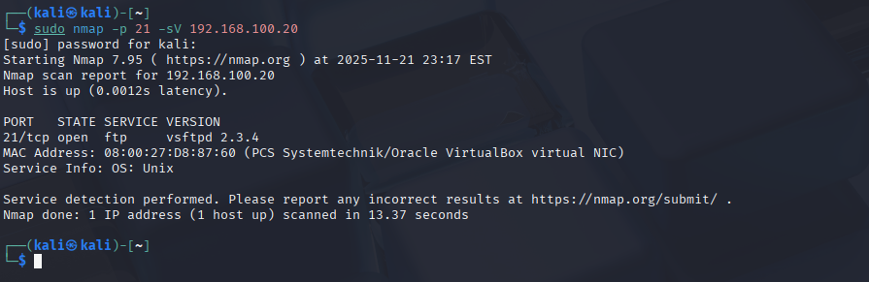
Attempt Anonymous Login
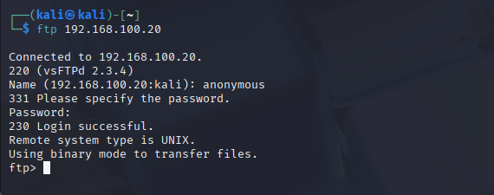
3.2 Telnet Service Enabled (Plain Text Authentication)
Telnet was running on port 23 and accepted default credentials.
Telnet sends all usernames and passwords without encryption.
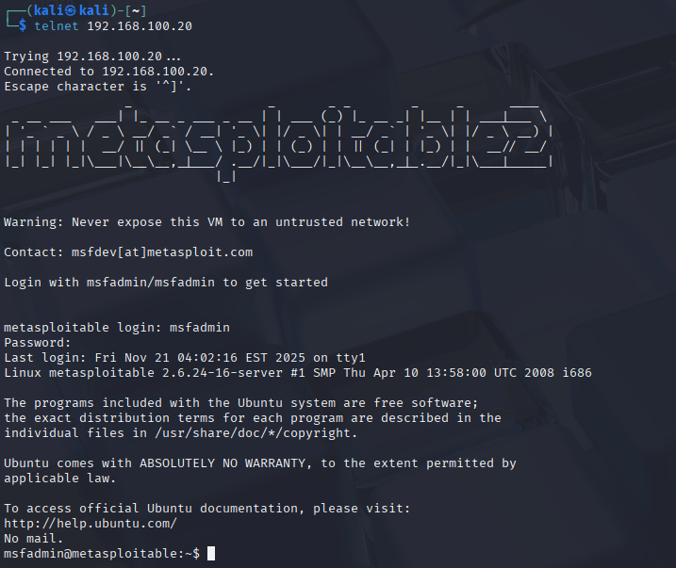
3.3 Outdated OpenSSH Version
OpenSSH version 4.7p1 was detected.
This is very old and contains known vulnerabilities.
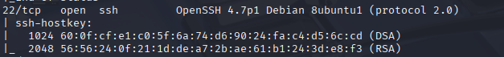

3.4 Apache Tomcat Default Page Exposed
The Tomcat default page was exposed on port 8180.
This leaks version information and access paths.
URL:
http://192.168.100.20:8180
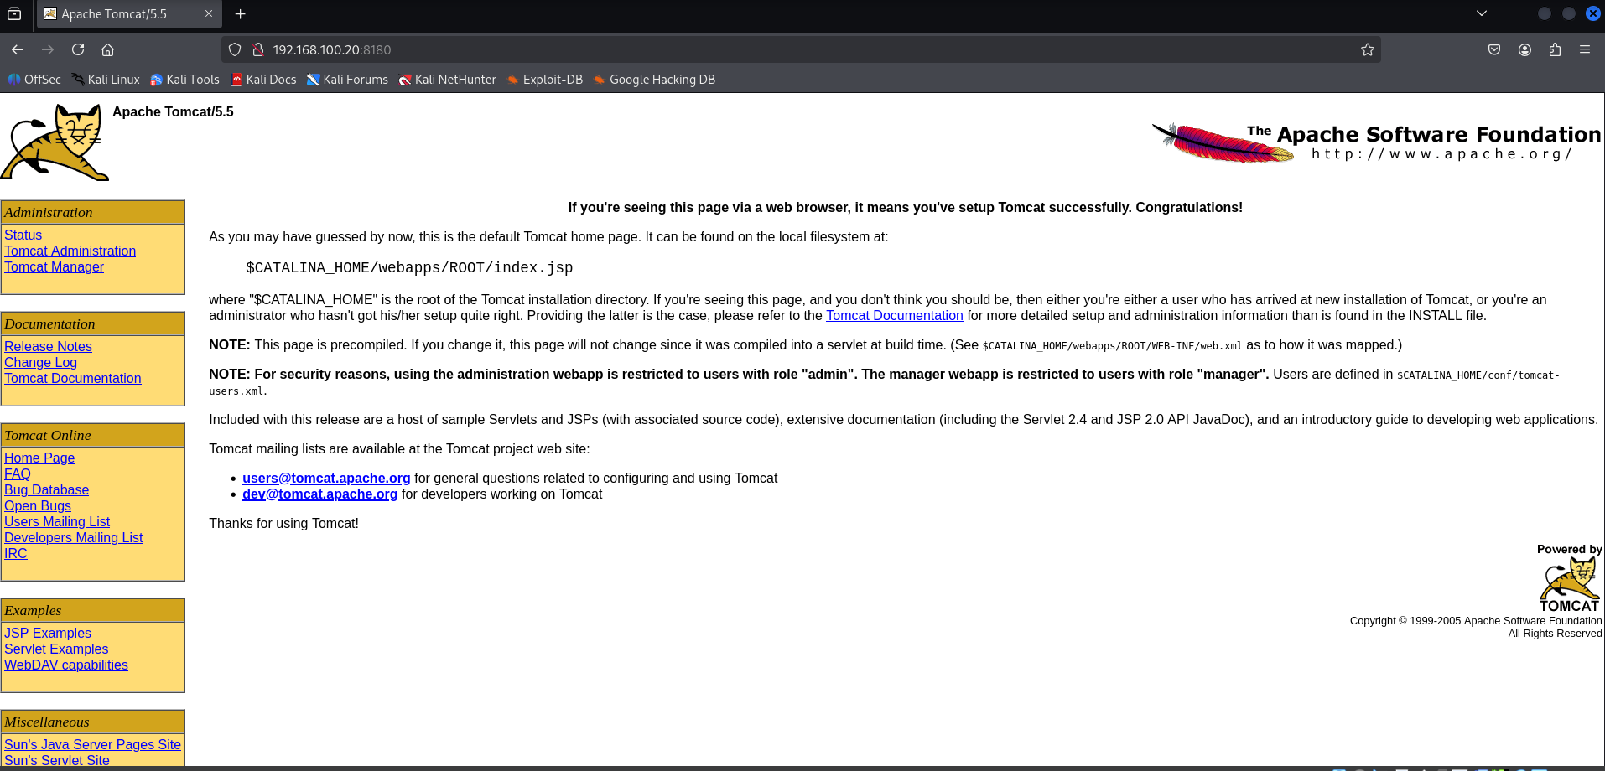

3.5 SMB Information Leak
SMB ports 139 and 445 were open and leaked OS and service information.
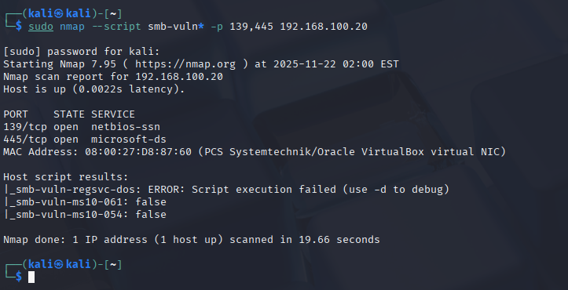

4. Exploitation Performed (Offensive)
Three misconfigurations were exploited to show real attack paths.
4.1 Exploit 1: FTP Anonymous Access
I logged in without any password and accessed file listings.
4.2 Exploit 2: Telnet Default Credentials
I logged in using default credentials and gained full shell access.
4.3 Exploit 3: Tomcat Default Interface
Access to Tomcat default page showed version details and admin paths.

http://192.168.100.20:8180

5. Impact Summary
These misconfigurations allowed:
- Unauthenticated login
- Remote shell access
- Information disclosure
- Exposure of sensitive services
- Outdated and unpatched software
Attackers could use these weaknesses to fully compromise the machine.

6. Recommendations
To fix the issues:
- Disable anonymous FTP
- Remove Telnet completely
- Update OpenSSH to latest version
- Remove Tomcat default pages
- Restrict SMB access
- Use firewall rules
- Apply strong password policies
- Update and patch all services

7. Conclusion
This home lab helped me understand how misconfigurations create real risks.
I learned how to scan systems, identify weaknesses, and exploit them in a safe environment.

